**Name: - Milkias Ghebremariam**

**Student Id: -109364**

**Name: -Tomas Melake**

**Student Id: -109334**

Answer 1,

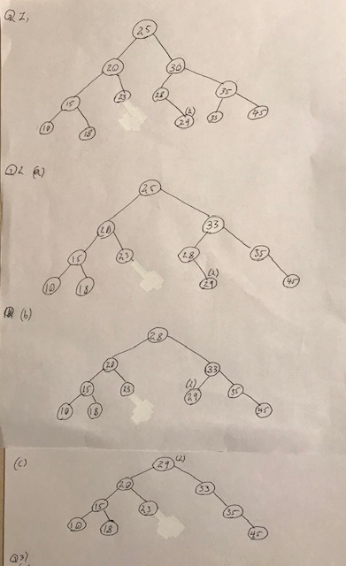

Answer 3.

(a). 25,20,15,10,18,23,30,28,29,29,35,33,45

(b). 10,18,15,23,20,29,29,28,33,45,35,30,25

(c). 10,15,18,20,23,25,28,29,29,30,33,35,45

Answer 4

(a). **private** **int** countNodes(Node n) {

**if** (n.right == **null** && n.left == **null**)

**return** 1;

**else**

**return** 1 + countNodes(n.left) + countNodes(n.right);

}

(b). **private** **int** countLeaves(Node n) {

**if** (isleaf(n))

**return** 1;

**else** **if** (isleaf(root.left))

**return** 1 + countNodes(root.right);

**else**

**return** 1 + countNodes(root.left);

}

**private** **boolean** isleaf(Node n) {

**if** (n.left == **null** && n.right == **null**)

**return** **true**;

**else**

**return** **false**;

}

(c). **public** **void** mirror(Node node) {

**if**(node == **null**) {

**return**;

}

mirror(node.left);

mirror(node.right);

Node temp;

temp = node.left;

node.left = node.right;

node.right = temp;

}